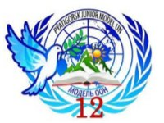

The list of the Countries
Country | Delegate
Russia
China
The United Kingdom
The United States
France
Egypt(2017)
Italy(2017)
Ukraine(2017)
Japan(2017)
Bolivia(2018)
Kazakhstan(2018)
Senegal(2017)
Uruguay(2017)
Sweden(2018)
Ethiopia(2018)

